MCBA Presentation Materials
May 24, 2017
Below are pictures of the posters and materials that the Montgomery County Beekeepers association has available for loan when doing talks/presentations about bees. The materials are stored at Jim’s shop, Maryland Honey Company in Gaithersburg, MD.
Maryland Honey Company
6910 Damascus Rd,
Gaithersburg, MD 20882
(301) 518-9678

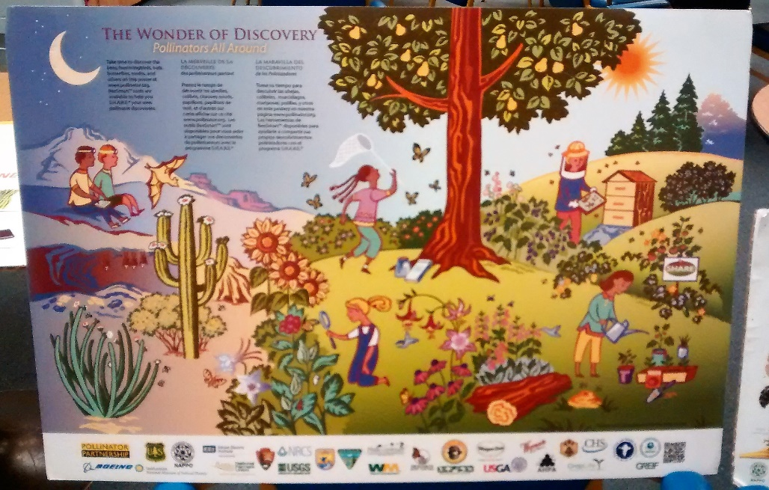

Poster, The Wonder of Discovery; mounted on foam board; approximately 24” x 36”

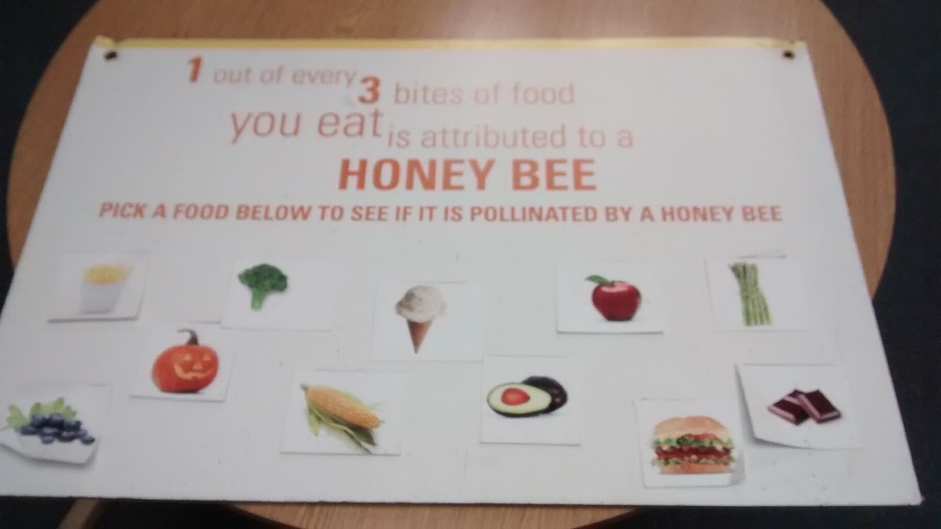
Poster, 1 of every 3 Bites; mounted on foam board; approximately 24” x 36”

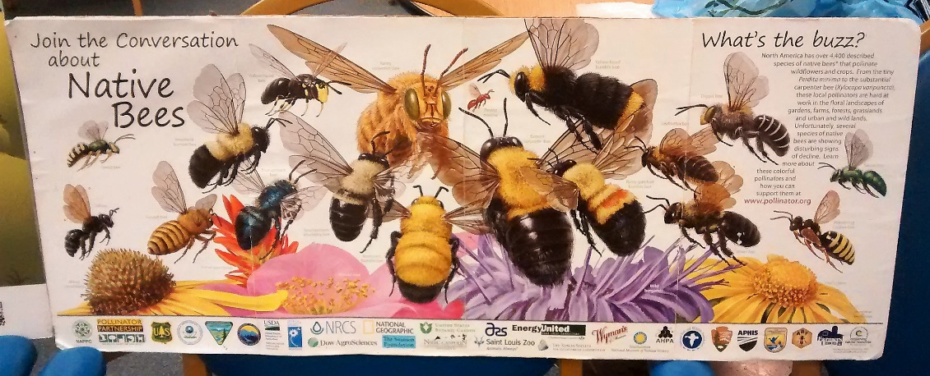

Poster, Native Bees; mounted on foam board; approximately 18” x 36”

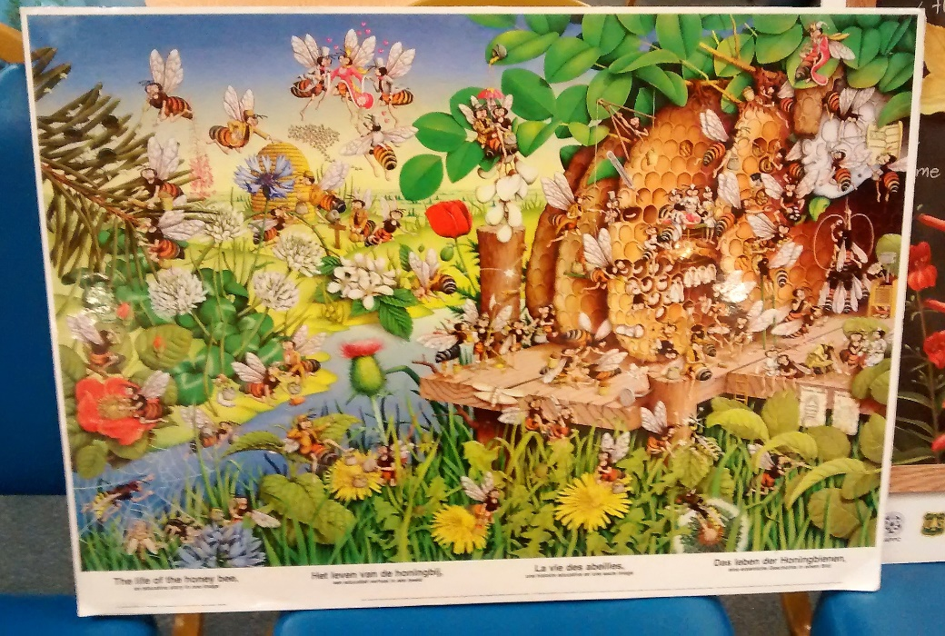

Poster, The Life of a Honey Bee; mounted on foam board; approximately 30” x 36”

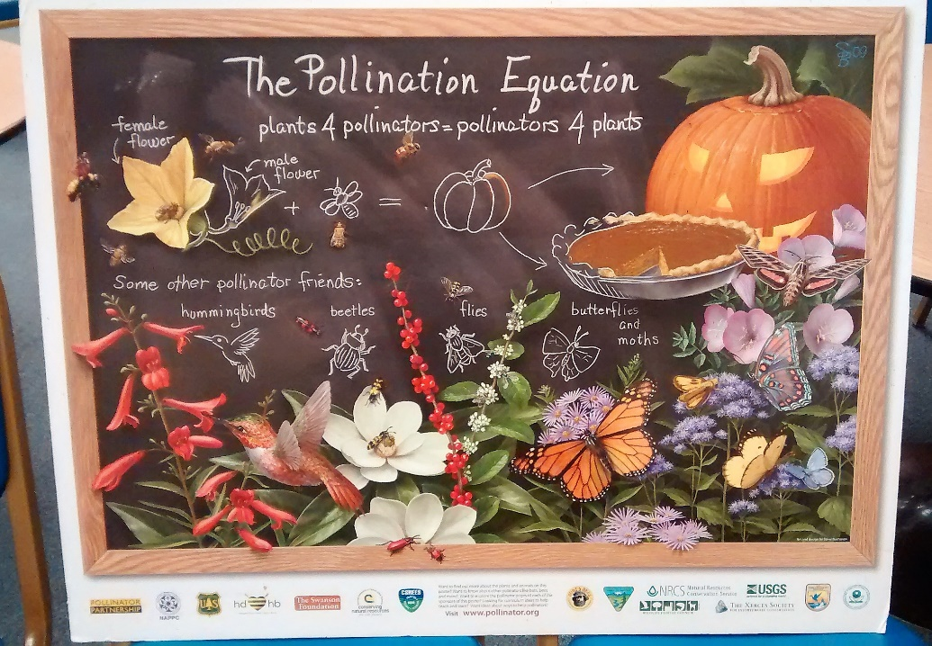
Poster, The Pollination Equation; mounted on foam board; approximately 30” x 36”

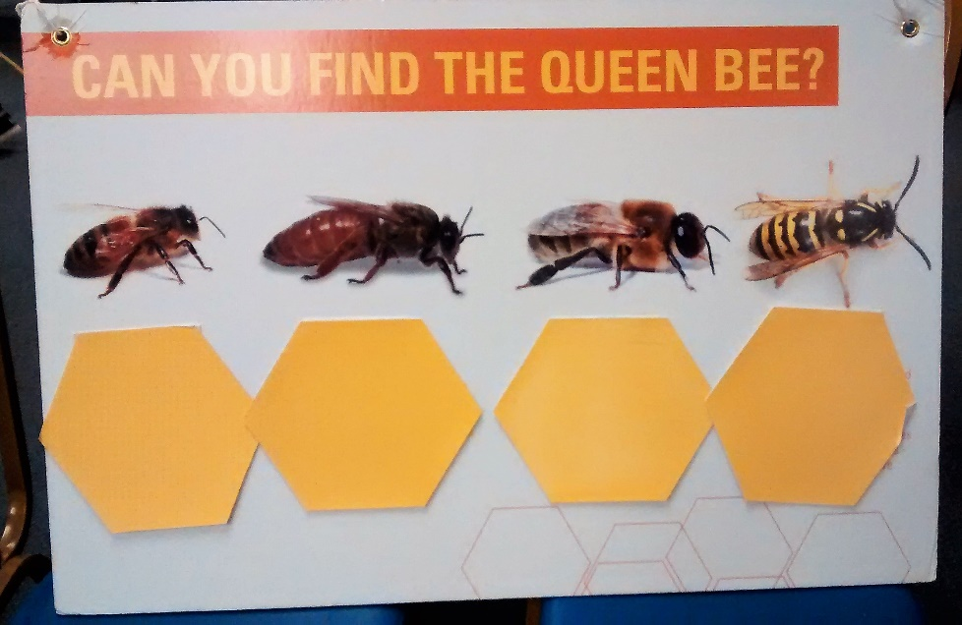

Poster, Can You Find the Queen?; mounted on foam board; approximately 28” x 36”

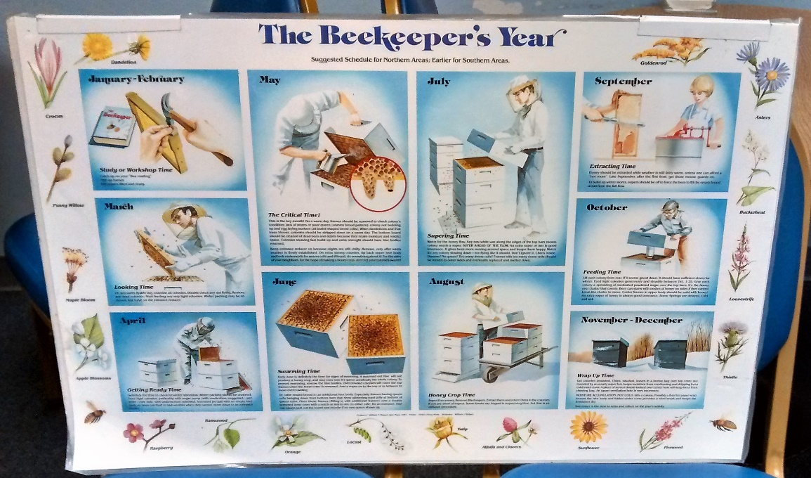

Poster, The Beekeeper’s Year; mounted on foam board; approximately 28” x 36”

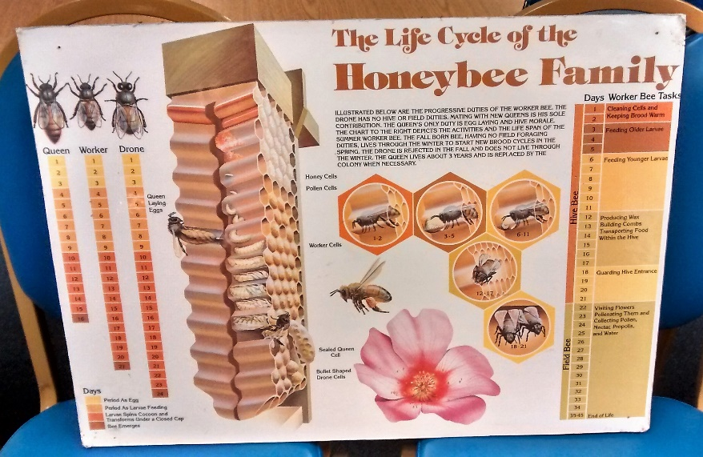
Poster, The Life Cycle of the Honey Bee Family; mounted on foam board; approximately 28” x 36”

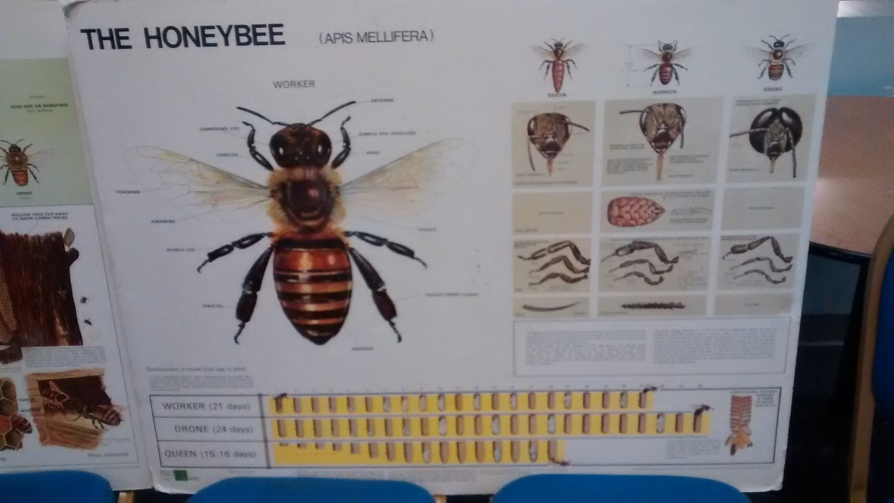

Poster, The Honey Bee; mounted on foam board; approximately 36” x 40”

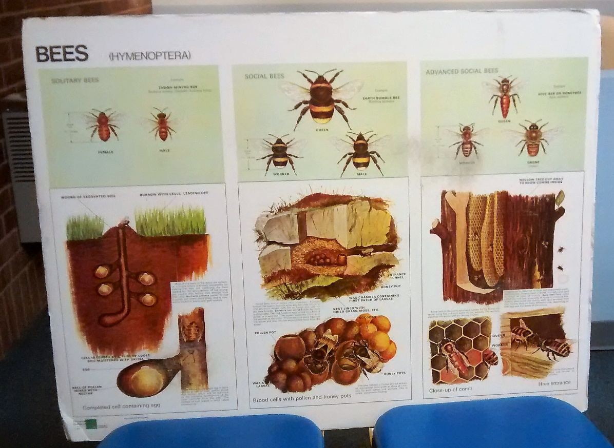

Poster, Bees; mounted on foam board; approximately 36” x 40”

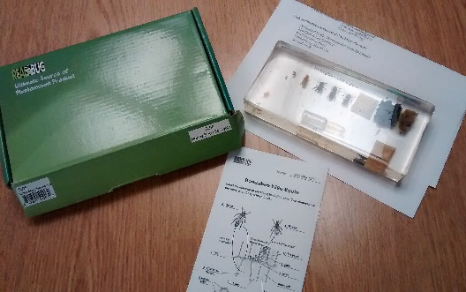

Bee and bee products preserved in clear resin (2)

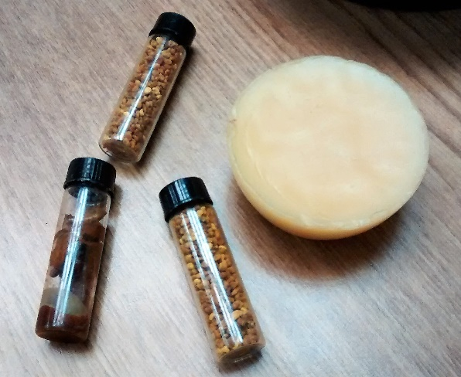

Samples of pollen, propolis and bees wax

